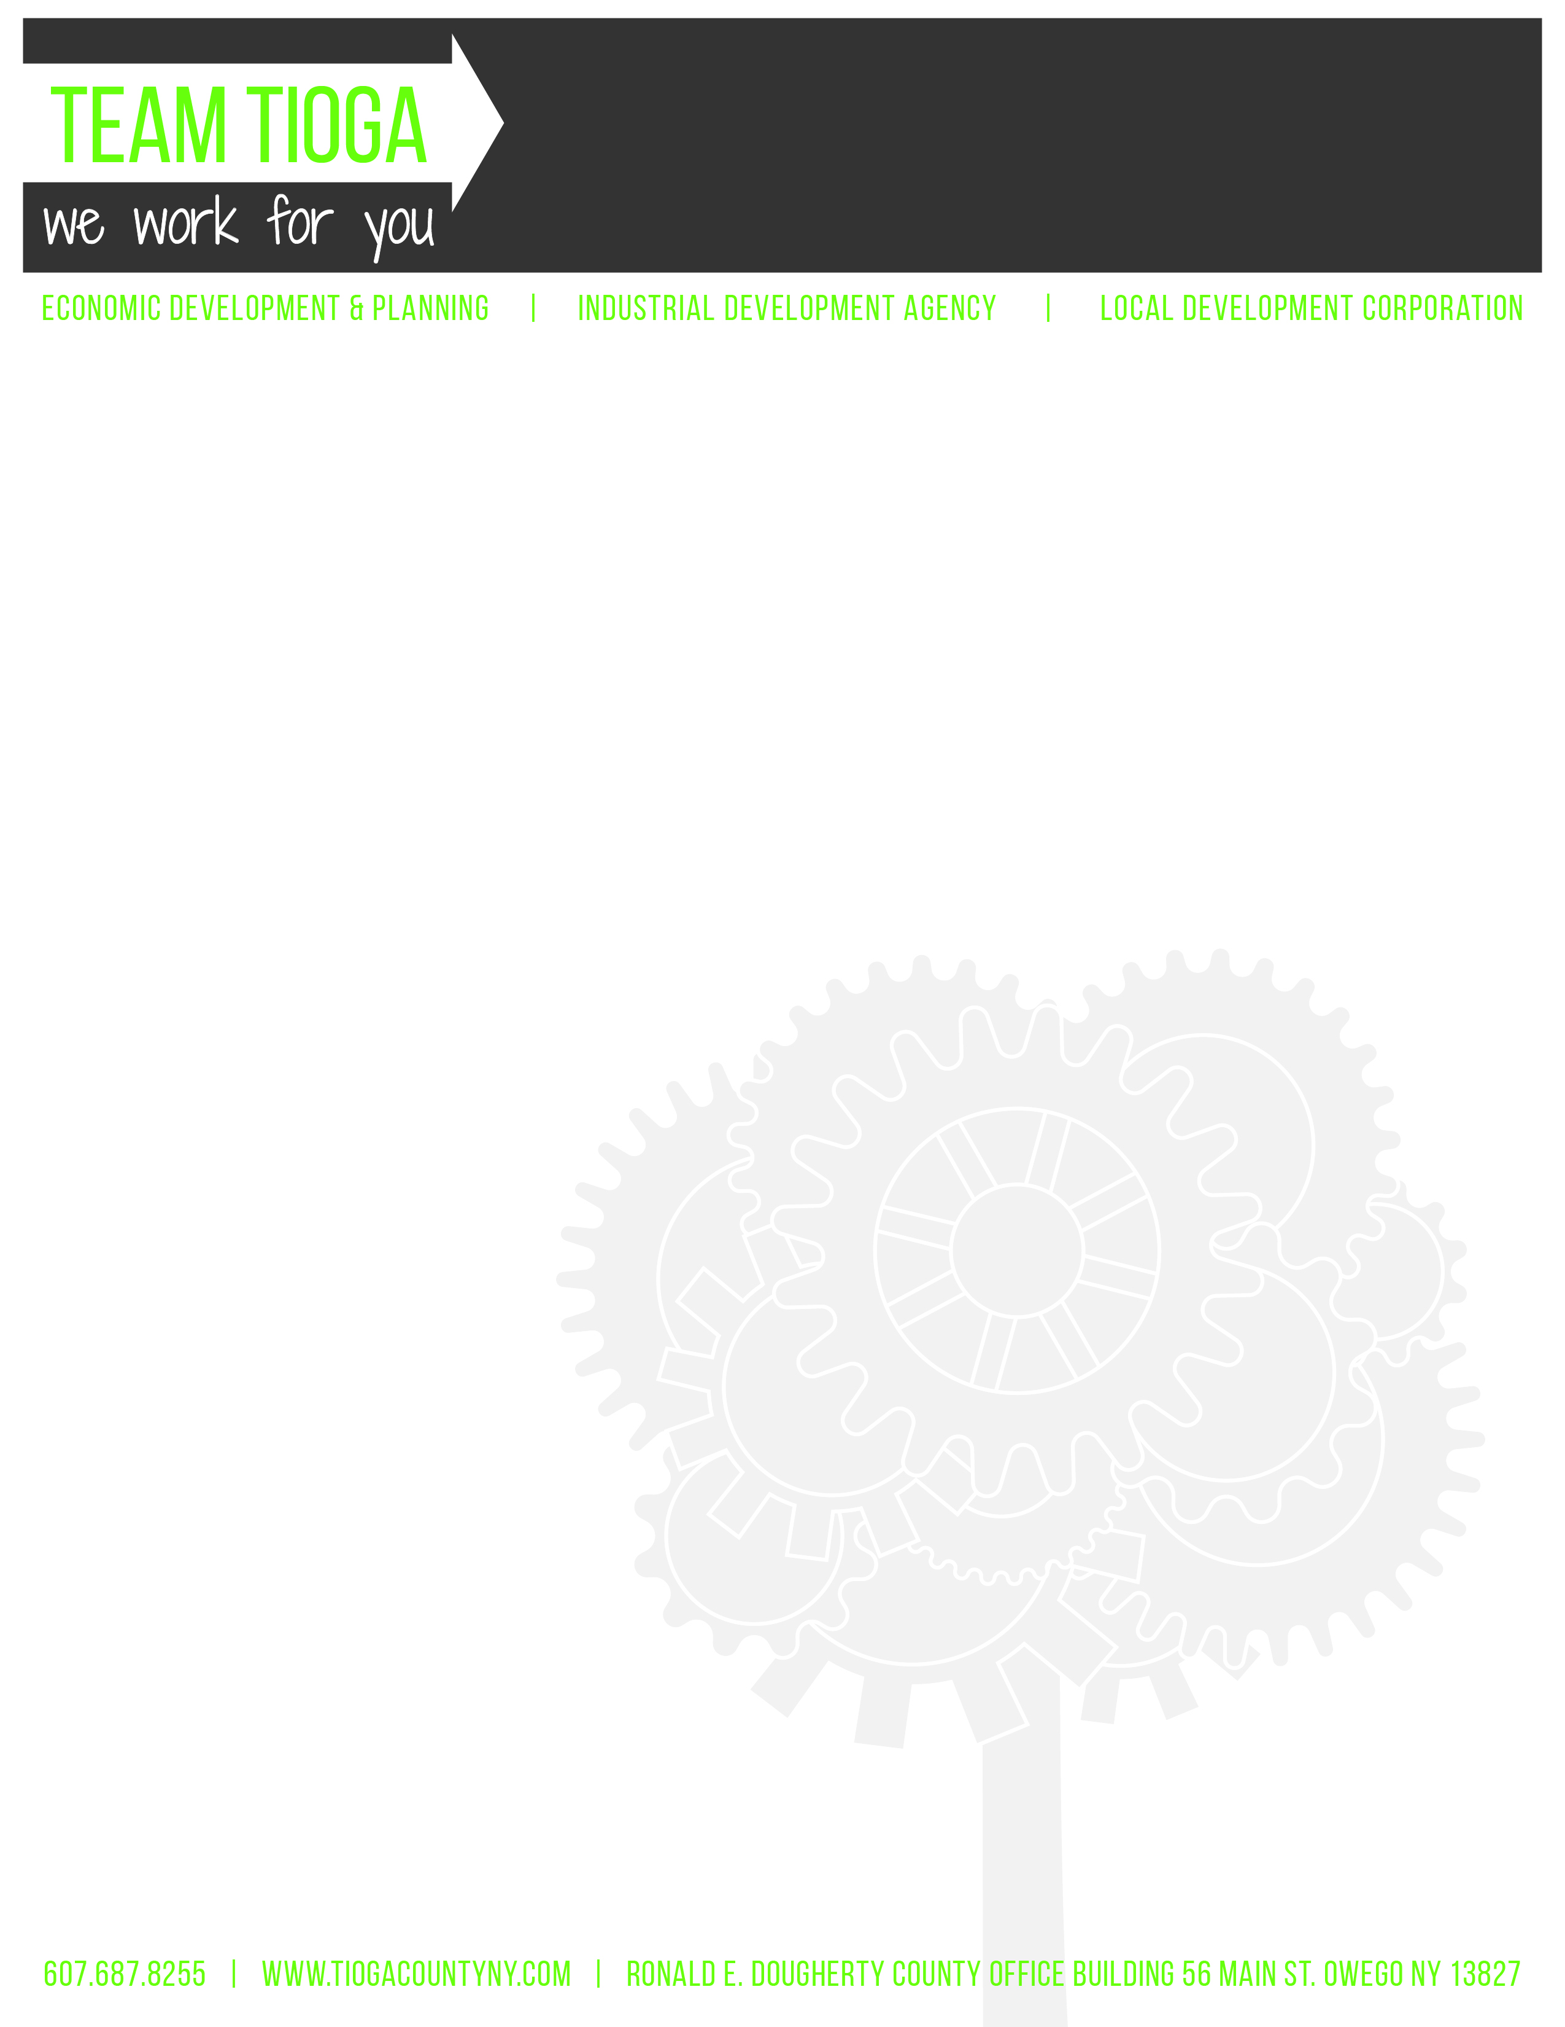

Tioga County Industrial Development Agency

October 2, 2019 • 4:30 p.m. • Ronald E. Dougherty County Office Building

56 Main Street, Owego, NY 13827

Regular Meeting Minutes

I. Call to Order and Introductions – Chairman R. Kelsey called the meeting to order at 4:32 p.m.

- Attendance
IDA Board Members:
  - Roll Call: R. Kelsey, A. Gowan, M. Sauerbrey, E. Knolles, T. Monell
  - Absent: None
  - Excused: J. Ceccherelli, K. Gillette
  - Guests: C. Curtis, L. Tinney, J. Meagher, C. Haskell, D. Griffin, L. McCafferty, M. Freeze

- Privilege of the Floor – Drew Griffin, Tioga County IT Deputy Director

C. Curtis introduced Drew Griffin, Tioga County IT Deputy Director. D. Griffin reviewed the following quotes for IDA Board consideration for compliance with the new live streaming legislation effective January 1, 2020 for all New York State IDA’s. D. Griffin provided the following quotes:
- Zoom - $550.00 annually
- WebEx - $1,188.00 annually
- GoTo Meeting - $854.00 annually

D. Griffin reported Zoom is currently used by County Departments and is highly reliable, user-friendly, with the capacity to capture only audio and screen shots and not necessarily people in the room, and provides a permanent link to the IDA webpage. Zoom will allow for live streaming and archiving of video on the website. D. Griffin reported Zoom is the least expensive, but is also the most effective and efficient option.

D. Griffin reported no additional equipment purchases are required as the Legislative Conference Room and Hubbard Auditorium are fully equipped.

Question raised regarding operation of software during the meeting and to ensure Executive Session discussion is not included. D. Griffin reported IDA staff would have the ability to start/pause/stop the software during the meeting.

Initially, there will be some minor set up by the County ITCS Department, however, downloading and posting videos can eventually be handled with IDA staff like any other documents posted to the IDA webpage.

Motion to approve purchase of Zoom software at the annual cost of $550.00 for the purpose of live streaming IDA Board meetings effective January 1, 2020, per new State legislation.

- Approval of Minutes
  - September 4, 2019 Regular Meeting Minutes

Motion to approve September 4, 2019 Regular Board meeting minutes, as written. (A. Gowan, T. Monell)

Aye – 5 Abstain – 0

No – 0 Carried
  - September 4, 2019 Loan Committee Meeting Minutes

Motion to approve September 4, 2019 Loan Committee minutes, as written. (T. Monell, A. Gowan)

Aye – 5 Abstain – 0

No – 0 Carried
  - September 23, 2019 Finance Committee Minutes

Motion to approve September 23, 2019 Finance Committee minutes, as written. (T. Monell, M. Sauerbrey)

Aye – 5 Abstain – 0

No – 0 Carried
  - September 23, 2019 Governance Committee Minutes

Motion to approve September 23, 2019 Governance Committee minutes, as written. (M. Sauerbrey, T. Monell)

Aye – 5 Abstain – 0

No – 0 Carried
- Financials –
  - Balance Sheet
  - Profit & Loss
  - Transaction Detail; Cash Accounts Only
  - Bank Reconciliations – Treasurer, A. Gowan reviewed the monthly bank reconciliations.

Motion to acknowledge financials, as presented. (A. Gowan, T. Monell)

Aye – 5 Abstain – 0

No – 0 Carried
- ED&P Update: L. Tinney
  - Housing Study – Phase II Executive Summary: L. Tinney reported Phase I was data collection/analysis and Phase II was the Implementation Plan. L. Tinney reported Phase II is completed. L. Tinney reported a Steering Committee, which includes Tioga County Property Development Corporation (Land Bank) and Tioga Opportunities, Inc. is currently reviewing the mission statement, goals, and objectives under the efforts of A. Hendrickson, ED&P Community Development Specialist.
  - Workforce Pipeline Study – L. Tinney reported Phase I was data collection/analysis and Phase II is just getting underway. L. Tinney will present the collected data at the Chamber of Commerce Economic Forum. L. Tinney reported TEAM Tioga worked with a consultant who conducted the outreach to the school districts.
  - Broome-Tioga Talent Task Force Group – L. Tinney contacted Broome County IDA Director Duncan to inquire about a Broome-Tioga partnership. L. Tinney reported Ms. Duncan was in favor of the partnership. L. Tinney reported one of the outcomes of this group was the K-20 Work Group and the interest to work with schools directly. L. Tinney encouraged E. Knolles to contact her or Ms. Duncan if he is interested in participating in this group.

ACTION: L. Tinney will email E. Knolles information regarding the K-20 Work Group for possible participation consideration.
  - Chamber of Commerce Economic Forum – L. Tinney reported this event is on October 16, 2019 from 3:30 – 5:30 p.m. at Tioga Golf Club. L. Tinney will be one of the event speakers providing an economic overview specifically on Tioga County.
  - Tioga County Data – L. Tinney reported ED&P has access to software for data specific to Tioga County’s employment (i.e., job vacancies, employers, salary ranges, occupations currently of interest, etc.).
  - Code Enforcement Officer Feasibility Study – L. Tinney reported REAP was able to secure funding for a countywide feasibility study.
  - REAP Strategic Plan – L. Tinney reported REAP was able to secure funding to update their Strategic Plan.
  - Local Foundation Coalition – L. Tinney reported ED&P Community Specialist, A. Hendrickson, is working with the local foundations to develop a universal application and website presence.
  - Tioga County Property Development Corporation (Land Bank) – L. Tinney reported nine demolitions have been completed. L. Tinney reported two rehabilitation projects and one additional demolition still needs to be completed. L. Tinney reported appraisals completed on the vacant lots for preparation of marketing/selling properties.
  - Agricultural Tire Recycling Program – Ag Community Development Specialist, M. Griffiths is currently working with the County’s Sustainability Manager on a tire recycling program for the farming community. In addition, M. Griffiths is working on Ag business spotlights.
- Project Updates: C. Curtis
  - V&S – C. Curtis reported construction in progress.
    - Capital Assistance –
      - Department of Budget – C. Curtis reported the Department of Budget approved the CAP funding.
      - Empire State Development – C. Curtis reported ESD approval is anticipated by October 17, 2019.
      - Notice of Award to Procon – C. Curtis reported ESD has approved the Notice of Award (NOA) to Procon for $242,000 for the water and sewer extension. The award is up to $300,000, therefore, question raised as to how the remaining funds could be secured and used. L. Tinney reported the water & sewer extension project could possibly have an electric component, therefore, working with ESD on possibly incorporating this component into the overall project. L. Tinney reported since this is State funding there is a MWBE requirement. L. Tinney reported no bids or material providers are MWBE eligible, therefore, in the process of requesting a waiver on this requirement. L. Tinney reported documentation and budget breakdown submitted for waiver consideration and eliminate inclusion in the grant agreement. Question raised as to whether the bid includes gravel and/or concrete. L. Tinney reported the bid includes only excavating, pipe, and pump station. L. Tinney reported the grant is with the IDA, therefore, the IDA will pay upfront costs and then submit for reimbursement.

Motion to accept the Notification of Award for $242,000 for the water and sewer extension. (A. Gowan, T. Monell)

Aye – 5 Abstain – 0

No – 0 Carried
    - Ground Breaking Event – C. Curtis reported the groundbreaking event is November 5, 2019 at 10:30 a.m. and all Board members are invited to attend.
  - Owego Gardens II –
    - Financing (Home Leasing) – C. Curtis reported Home Leasing is currently in the process of securing financing and anticipates construction to commence fall 2020.
    - Water Tank – C. Curtis reported the water tank cost estimated at $1.2 million. Of this cost, ESD is contributing $350,000, Home Leasing is contributing $221,500 and the IDA is contributing $676,500, which was previously approved. C. Curtis reported sub-agreement is in progress with Home Leasing for their $221,500 contribution. L. Tinney reported the project would not commence until all funding is in place and the earliest anticipated date is January 2020.
  - DRI –
    - Homes and Community Renewal (HCR) Agreement – C. Curtis anticipates receiving this agreement within the month.

Motion to authorize any IDA Board officer to sign the agreement, contingent upon J. Meagher’s review. (T. Monell, E. Knolles)

Aye – 5 Abstain – 0

No – 0 Carried
    - Sub-recipient Agreements – L. Tinney reported the agreement is between HCR and IDA, however, each individual project will require their own sub-recipient agreement. C. Curtis reported the Loan Committee would review the agreements prior to the November IDA meeting for Board consideration.

- New Business: C. Curtis
  - William Caloroso Resolution – C. Curtis reported a resolution is included in tonight’s meeting packet for former IDA Board member/Legislator who passed away last month. L. Tinney will present to Mr. Caloroso’s wife.

Motion to authorize resolution for former IDA Board member/Legislator William Caloroso.

Aye – 5 Abstain – 0

No – 0 Carried
  - Engineering Excellence Award – C. Curtis reported Tioga County IDA was honored to receive the Engineering Excellence Award presented by Larson Design Group for the work accomplished at the wastewater treatment facility in Lounsberry.
  - Project List – C. Curtis reported she and L. Tinney are in the process of compiling a list of all IDA properties to include identification of studies completed and ones that still need completion.
  - TEAM Tioga Breakfast – L. Tinney reported she and C. Curtis, along with the ED&P Secretary, are currently working on an event budget to host an IDA/TEAM Tioga breakfast networking event in Tioga County. The purpose of the event is share TEAM Tioga’s accomplishments with the community and municipal leaders. Quotes received for Tioga Downs’ ballroom and Tioga Golf Club. A. Gowan reported he believes a smaller invitation list will allow for more networking effectiveness.
    - Sub-Committee – L. Tinney reported there is a great deal of work in planning this event, therefore, requested a Board member to volunteer to serve on the sub-committee. M. Sauerbrey agreed to serve on this event planning sub-committee.
    - Tentative Budget – L. Tinney reported ED&P will contribute $2,500 and inquired about IDA budget contribution. The IDA Board agreed to a $5,000 contribution towards this event, therefore, an overall event budget of $7,500.

Old Business: C. Curtis
  - Public Authority Accountability Act (PAAA)
    - Audit Committee Report: R. Kelsey, A. Gowan, E. Knolles
      - Annual Audit Recommendation – C. Curtis reported three bids received and reviewed by the Audit Committee. The Audit Committee is recommending Insero & Co., as they were the lowest bid for a three-year period. The first year is $7,000, second year is $7,300, and third year is $7,600.

Motion to accept Audit Committee’s recommendation to proceed with Insero & Co. for the IDA’s annual audit for the next three years at the above-referenced rates. (T. Monell, E. Knolles)

Aye – 5 Abstain – 0

No – 0 Carried

    - Governance Committee: J. Ceccherelli, A. Gowan, R. Kelsey
      - C. Curtis Training – NYS Comptroller Introduction to Governmental Accounting School – The Governance Committee is recommending C. Curtis attend a 2.5 day Introduction to Governmental Accounting School through the NYS Comptroller’s Office and requested Board approval.

Motion to accept Governance Committee’s recommendation for C. Curtis to attend the 2.5 day NYS Comptroller Introduction to Governmental Accounting School. (A. Gowan, T. Monell)

Aye – 5 Abstain – 0

No – 0 Carried
    - Finance Committee: R. Kelsey, A. Gowan, and K. Gillette
      - 2020 PARIS Budget – C. Curtis reported the Finance Committee reviewed the 2020 PARIS report that is due by 10/30/19 and recommended Board approval.

Motion to accept the Finance Committee’s recommendation to adopt and submit the 2020 PARIS report by the established deadline. (E. Knolles, T. Monell)

Aye – 5 Abstain – 0

No – 0 Carried
      - Financial Policy – C. Curtis reported the Finance Committee reviewed the previously discussed policy for transference of funds exceeding $150,000 in the general checking account to the ICS account.

Motion to accept the Finance Committee’s recommendation to adopt the new financial policy referencing transference of funds exceeding $150,000 in the general checking account to the ICS account. (A. Gowan, T. Monell)

Aye – 5 Abstain – 0

No – 0 Carried
    - Loan Committee: (S. Thomas, R. Kelsey, A. Gowan, D. Barton, K. Dougherty)
      - Nothing to report.
    - Annual Policy Review – C. Curtis reported Board members are required to review the annual policies prior to the annual meeting in January.

ACTION: C. Curtis will email the IDA policies to Board members for their review.
    - Sexual Harassment Prevention Training – L. Tinney reminded Board members of the Sexual Harassment Prevention Training requirement. Board members A. Gowan, T. Monell, M. Sauerbrey, and E. Knolles acknowledged training completion.
- PILOT Updates: C. Curtis
  - Sales Tax Exemptions Update: C. Curtis
    - V&S Sales Tax Exemption Report – C. Curtis reported V&S is submitting monthly sales tax reports and, to date, the company has used $290,951.84 of their allowable amount of $671,200. C. Curtis reported she is reviewing and monitoring all ST-123 activity.
  - Best Buy Agency Fee - C. Curtis reported the agency fee was invoiced on 9/18/19 for $16,070, however, to date, has not been paid.
  - School PILOTs – C. Curtis reported school PILOTs invoiced on 9/13/19 and, to date, three of the five have been received.
  - Delaware River Solar, LLC – C. Curtis reported the Board should anticipate a PILOT application next month. This 10-acre 2 to 5-megawatt solar farm is currently being sought in the Town of Candor; however, location has not been announced. C. Curtis reported she is anticipating a 20-year PILOT request.
  - Spencer-Tioga Solar – C. Curtis reported the PILOT is in place and construction is completed.
  - Solar Farm PILOTs – L. Tinney reported she and C. Curtis are compiling a list of all the solar farm PILOT’s, which includes Community Host Agreements, Town PILOTs and IDA PILOTs.
  - Central NY Oil & Gas, LLC (n/k/a Stagecoach Gas Services, LLC) PILOT Extension Request – L. Tinney reported she and C. Curtis met with the municipalities, at the request of the Owego-Apalachin Central School District (OACSD), regarding a PILOT extension request. L. Tinney reported the PILOT expired last year and at that time, OACSD requested an extension to February 2020, which the IDA approved. L. Tinney reported OACSD is now requesting an additional extension to March 2, 2020 as the $97 million assessment to Roll Section 1 will create a significant issue for the school’s tax cap calculation. L. Tinney reported all taxing entities (County, School, and Town) need to adopt a resolution in support of the request in order to grant the extension. If all entities are in support, L. Tinney will prepare and present a resolution to the IDA Board in November to extend the PILOT to March 2, 2020.

- Motion to move into Executive Session pursuant to Public Officers Law Section 105 at 5:34p.m. to discuss financial and personnel matters. (T. Monell, A. Gowan)

Aye – 5 Abstain – 0

No – 0 Carried

Executive Session adjourned at 5:42 p.m.

- Next Meeting: Wednesday, November 6, 2019 at 4:30 p.m. Legislative Conference Room. A. Gowan reported he would not be in attendance at the November meeting. R. Kelsey reported he would not be in attendance at the December meeting.
- Adjournment – Meeting adjourned at 5:42 p.m.

Respectfully submitted,
Cathy Haskell
IDA Executive Assistant

