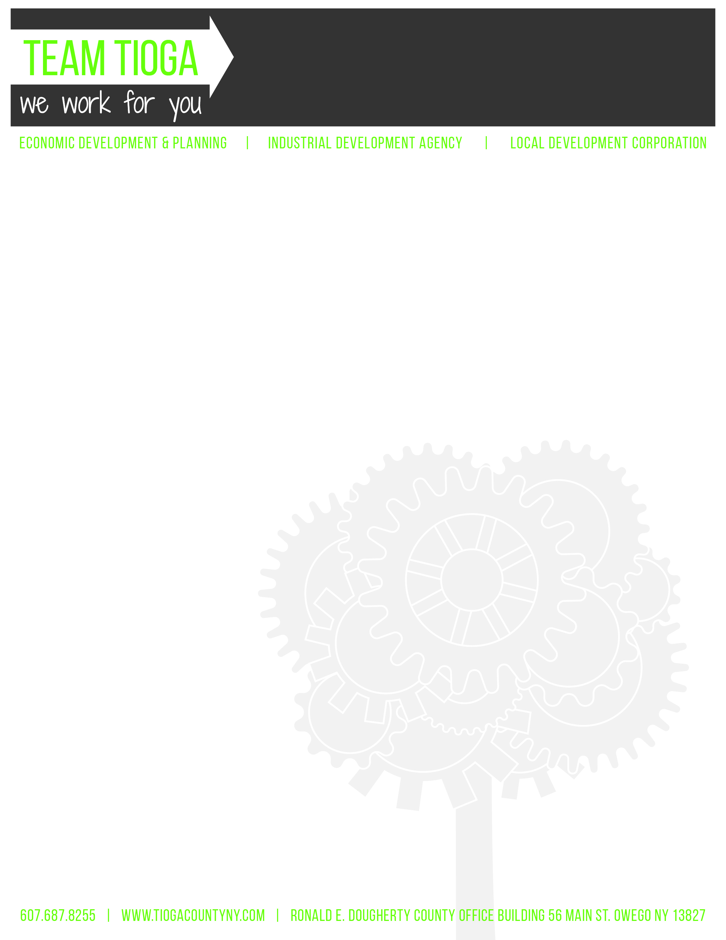

Tioga County Industrial Development Agency

April 3, 2019 • 4:30 p.m. • Ronald E. Dougherty County Office Building

56 Main Street, Owego, NY 13827

Regular Meeting Minutes

I. Call to Order and Introductions – Chairman R. Kelsey called the meeting to order at 4:31 p.m.

- Attendance
IDA Board Members:
  - Roll Call: R. Kelsey, A. Gowan, J. Ceccherelli, K. Gillette, T. Monell (arrived @ 4:37 p.m.)
  - Absent: K. Dougherty
  - Excused: M. Sauerbrey
Guests: C. Curtis, L. Tinney, Z. Baker, P. Siegard, M. Freeze, C. Haskell (arrived @ 5:00 p.m.),

- Privilege of the Floor –
- Patricia Siegard, Membership Development Coordinator of International Brotherhood of Electrical Workers Local Union 241, addressed the Board with regard to the labor employed at the solar project in Spencer, NY.
- Zack Baker, ED&P Ag Development Specialist presented a Hemp Opportunities & Challenges report regarding the Fiber Hemp and CBD Hemp industries. Mr. Baker informed the Board of the 2018 Federal Farm Bill that removed hemp from Schedule 1 controlled substance list, the NYS licensing process, labor and equipment involved, crop nutrient needs, and the present average return on investment.

- Approval of Minutes
  - March 6, 2019 Regular Meeting Minutes

Motion to approve March 6, 2019 regular meeting minutes, as written. (K. Gillette, R. Kelsey)

Aye – 5 Abstain – 0

No – 0 Carried

- Financials
  - Balance Sheet
  - Profit & Loss
  - Transaction Detail; Cash Accounts Only

Motion to acknowledge financials, as presented. (K. Gillette, A. Gowan)

Aye – 5 Abstain – 0

No – 0 Carried
- Project Updates:
  - Project Steel
    - Commitment Letter CAP Funds – Tioga County ED&P received a letter stating Senate Finance has confirmed the Division of Budget will be moving forward with the $300,000 grant to assist with the extension of utilities for the V&S project in Owego, NY.
    - Land Purchase Closing – C. Curtis reported the land purchase closing for the V&S project is complete.

- New Business: C. Curtis
  - Prevailing Wage Resolution – Resolution opposing NYS Senate Bill S.1947 and NYS Assembly Bill A.1261 related to hours, wages, and supplements in contracts for public work presented for IDA Board consideration. L. Tinney reported surrounding counties are adopting resolutions, as well as sending letters to respective elected officials and recommended the IDA Board do the same.

Motion to authorize resolution opposing NYS Senate Bill S.1947 and NYS Assembly Bill A.1261 related to hours, wages, and supplements in contracts for public work and sending letters to respective elected officials. (J. Ceccherelli, K. Gillette)

Aye – 5 Abstain – 0

No – 0 Carried
- Old Business: C. Curtis
  - Public Authority Accountability Act (PAAA)
    - Audit Committee Report: R. Kelsey, A. Gowan, K. Dougherty
- 2018 Year-End Audit – C. Curtis reported the 2018 year-end audit is completed and final hardbound copies arrived just prior to today’s meeting. L. Tinney reported there were no significant findings. R. Kelsey reported there were two minor recommendations that the IDA will address in writing.

Motion to accept the 2018 year-end audit as presented. (T. Monell, J. Ceccherelli)

Aye – 5 Abstain – 0

No – 0 Carried

    - Governance Committee Report: J. Ceccherelli, R. Kelsey, A. Gowan
      - Employee Handbook and Procurement Policy Revisions – C. Curtis reported the Employee Handbook and Procurement Policy were revised with minor changes regarding title change from Executive Director to Executive Administrator.

Motion to approve revisions to Employee Handbook and Procurement Policy, as presented. (J. Ceccherelli, K. Gillette)

Aye – 5 Abstain – 0

No – 0 Carried
    - PARIS Report – C. Curtis reported the PARIS report was completed and submitted on April 1, 2019 (deadline fell on Sunday, March 31st, therefore, was afforded next business day for submission).

  - ED&P Update: L. Tinney provided the IDA Board with a packet of information highlighting the following:
- Workforce Development Pipeline Strategy Study – Surveys conducted with a 42% response rate. Phase II funding through USDA REAP has been submitted for $38,000 to conduct the next level of the pipeline study.
- Phase II Housing Study – Creation of a Community Investment Task Force is completed and target neighborhoods identified in the Villages of Owego, Newark Valley, and Waverly.
- Village of Owego DRI – Local Planning Committee meetings are underway. Projects submitted for $13.6 million dollars; however, maximum award is $10 million. Award announcement anticipated for July/August 2019. Team Tioga is currently reviewing the DRI projects and formulating a plan for addressing each project with assignment of staff roles and responsibilities.
- Social Media Review – Consultant meets with Team Tioga periodically to discuss content. Facebook followers increased from 786 to 826.
- ED&P Staffing:
- Deputy Director Retirement – Teresa Saraceno, Deputy Director of Economic Development, announced her retirement after 20 years of service to Tioga County as of April 27, 2019. Ms. Saraceno will be returning to part-time employment as the County’s Executive Director of Tioga County Property Development Corporation (Land Bank) immediately following retirement. Question raised regarding façade loan lending and L. Tinney reported all lending would transfer to IDA Executive Administrator.
- New Deputy Director – Economic Development Specialist Brittany Woodburn appointed new Deputy Director of ED&P upon Ms. Saraceno’s retirement.
- Community Development Specialist – The County agreed to create the position of Community Development Specialist in the ED&P Department and recruitment is actively underway. This position is one of a planning role with municipal contact.
- Ag Development Specialist – During this restructuring process, Z. Baker will be assuming additional responsibilities.
- 2018 Annual Report
    - Industrial Park Signage – IDA Board should anticipate a proposal in the near future from Weitsman and V&S for new signage at the Industrial Park.

- PILOT Updates: C. Curtis
  - Town & County PILOT Bills – C. Curtis reported the last two PILOT payments have been received, therefore, all have been paid.
  - PILOT School Projections Distributed – C. Curtis reported PILOT all school projections have been distributed.
  - Hadco/Sanmina – C. Curtis reported upon review of the Hadco/Sanmina PILOT, she determined the IDA under billed a total of $886.93 for 2017-2018. In light of this, C. Curtis will send a bill to Sanmina for this outstanding amount. Question raised as to whether this was determined during the audit. Determination made by an in-house review conducted by C. Curtis.
  - CNYOG – OACSD Summary Request – L. Tinney reported OACSD School Superintendent Green previously addressed the IDA with the request to extend their soon-to-be expired PILOT for an additional year due to the impact on their tax rolls. The IDA Board agreed to the one-year extension in anticipation of State legislation adopted to assist with this type of transition. L. Tinney reported Mr. Greene indicated there is no action on the State’s part at this time, therefore, this same situation will present itself again next year. L. Tinney reported ED&P would continue to work with the school, town, county, and company to discuss possible solutions. L. Tinney reported extending a PILOT is taking no action for termination. Although taking no action grants an extension, IDA Board should continue to vote on all PILOT extensions, as presented. L. Tinney reported the IDA should anticipate further discussion on this issue.

- Reports: C. Curtis
  - Railroad Committee Report: T. Monell, K. Gillette, M. Sauerbrey
      - Income to Date – Currently, down approximately $4,000 from this time last year. C. Curtis reported the 2019 amount is solely representative of January 2019, as monthly payments received are generally for the prior two-month period, therefore, the payment received in March was for January 2019.
      - ECC Technologies Lease Request – C. Curtis reported S. May granted approval for this lease request. C. Curtis reported this is an annual lease of $200.00, which is the standard fee for across the tracks leases. L. Tinney reported the annual lease amount is subject to annual CPI increases.

Motion to approve new annual lease for ECC Technologies for $200.00 subject to annual CPI increases. (K. Gillette, T. Monell)

Aye – 5 Abstain – 0

No – 0 Carried

      - RR Leases – C. Curtis reported, to date, seven (7) lease bills sent and three (3) received. C. Curtis proposed sending all annual lease payments in January versus yearly periodic billing. The IDA Board was in agreement with this proposal. C. Curtis will prorate payment for the remainder of the 2019 lease bills that still need to be sent and starting in January 2020 all railroad lease payments will be billed at same time.
  - Finance Committee Report: R. Kelsey, A. Gowan, K. Gillette
    - Bank Signature Cards – C. Curtis reported all bank signature cards updated.
  - 2019 Annual Policy Review Attestation and Financial Disclosures – C. Curtis distributed hardcopies of these documents for IDA Board member completion and submission.
  - Audit RFP – R. Kelsey suggested starting the process of a RFP for next year’s audit with a three-year contract.

- Motion to move into Executive Session pursuant to Public Officers Law Section 105 at 5:26 p.m. to discuss financial matters and IDA properties. (T. Monell, J. Ceccherelli)

Aye – 5 Abstain – 0

No – 0 Carried

Executive Session adjourned at 5:58 p.m.

- Next Meeting – Wednesday, May 1, 2019, at 4:30 p.m. in the Legislative Conference Room.
- Adjournment –Meeting adjourned at 5:58 p.m.

Respectfully submitted,
Cathy Haskell
IDA Executive Assistant

