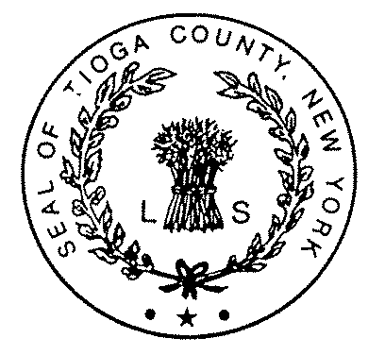TIOGA COUNTY DEPARTMENT OF SOCIAL SERVICES
Shawn L. Yetter, Commissioner  Gary Grant, Deputy Commissioner

P.O. Box 240 ∙ Owego, N.Y. 13827-0240 ∙ Telephone: (607) 687-8300 ∙ Fax: (607) 687-6168 ∙ NY Relay dial 711
Website: www.tiogacountyny.com

TIOGA COUNTY DEPARTMENT OF SOCIAL SERVICES - AGENDA
HEALTH & HUMAN SERVICES LEGISLATIVE COMMITTEE MEETING
May 8, 2018

BUDGET
- Gary Grant

CASELOADS
- During April, Cash Assistance cases increased 3 cases, with Family Assistance decreasing 6 cases and Safety Net increasing 9 cases.
- MA-Only decreased 5 cases.
- MA-SSI decreased 5 cases.
- Total individuals on Medicaid decreased 2 to 3,603.
- SNAP decreased 14 cases.
- Day Care increased 3 cases.
- Services increased 2 cases.
- See Caseload Summary.

PROGRAMMATIC HIGHLIGHTS
- Tioga Career Center Report.
- Raise the Age.

- PERSONNEL CHANGES
- Kimberly Clark retired 4/28/18.

- RESOLUTIONS
- Recognize Michele I. Robins for her 34 Years of Dedicated Service.
- Approve Funding – 2018 Youth Bureau Program Funding.
- Reauthorize Contract – Superior Group – Tioga Career Center.

- PROCLAMATIONS
- Elder Abuse Prevention Month.
- Foster Care Recognition Month.

