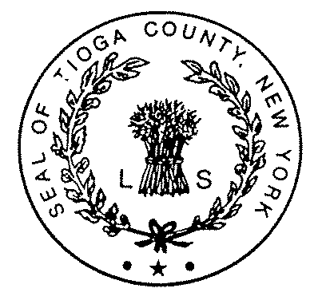TIOGA COUNTY DEPARTMENT OF SOCIAL SERVICES
Shawn L. Yetter, Commissioner  Gary Grant, Deputy Commissioner

P.O. Box 240 ∙ Owego, N.Y. 13827-0240 ∙ Telephone: (607) 687-8300 ∙ Fax: (607) 687-6168 ∙ NY Relay dial 711
Website: www.tiogacountyny.com

TIOGA COUNTY DEPARTMENT OF SOCIAL SERVICES - AGENDA
HEALTH & HUMAN SERVICES LEGISLATIVE COMMITTEE MEETING
June 5, 2018

BUDGET
- Gary Grant

CASELOADS
- During May, Cash Assistance cases increased 2 cases, with Family Assistance remaining flat and Safety Net increasing 2 cases.
- MA-Only increased 10 cases.
- MA-SSI decreased 8 cases.
- Total individuals on Medicaid increased 13 to 3,616.
- SNAP decreased 25 cases.
- Day Care increased 1 case.
- Services increased 2 cases.
- See Caseload Summary.

PROGRAMMATIC HIGHLIGHTS
- Tioga Career Center Report.

- PERSONNEL CHANGES
- Michele Robins retired 5/26/18.

- RESOLUTIONS
- Recognize Corrine J. Whitmore for 28 Years of Dedicated Service.
- Authorize Change Status for One (1) Full Time Social Services Investigator Position.
- Create Caseworker Position.

- PROCLAMATIONS
- None.

