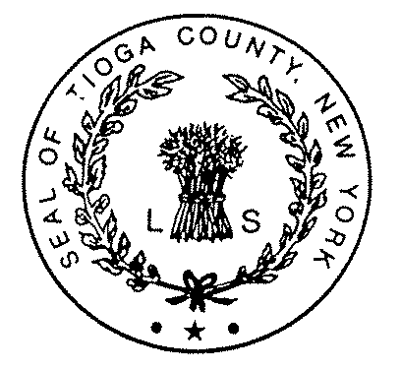TIOGA COUNTY DEPARTMENT OF SOCIAL SERVICES
Shawn L. Yetter, Commissioner  Gary Grant, Deputy Commissioner

P.O. Box 240 ∙ Owego, N.Y. 13827-0240 ∙ Telephone: (607) 687-8300 ∙ Fax: (607) 687-6168 ∙ NY Relay dial 711
Website: www.tiogacountyny.com

TIOGA COUNTY DEPARTMENT OF SOCIAL SERVICES - AGENDA
HEALTH & HUMAN SERVICES LEGISLATIVE COMMITTEE MEETING
July 3, 2018

BUDGET
- Gary Grant

CASELOADS
- During June, Cash Assistance cases decreased 6 cases, with Family Assistance decreasing 6 cases and Safety Net remaining flat.
- MA-Only decreased 13 cases.
- MA-SSI decreased 8 cases.
- Total individuals on Medicaid increased 39 to 3,577.
- SNAP increased 8 cases.
- Day Care decreased 3 cases.
- Services decreased 3 cases.
- See Caseload Summary.

PROGRAMMATIC HIGHLIGHTS
- Tioga Career Center Report
- SYEP 2018

- PERSONNEL CHANGES
- Probationary SWE, terminated 6/19/18.
- Tricia Soper, hired as Caseworker effective 6/25/18.
- Corrine Whitmore retired 6/30/18.

- RESOLUTIONS
- Authorize Chair of Legislature to Sign Memorandum of Understanding “Raise The Age” Compliance Coalition.
- Appropriation of Funds.

- PROCLAMATIONS
- None.

